MACHINE LEARNING

PHASE - 1

**TEAM MEMBERS**

Kollisetty Pushpak (AM.EN.U4CSE17308)

Tungala Yashwanth (AM.EN.U4CSE17340)

Yerramsetti Raghuram (AM.EN.U4CSE17359)

**DATA SET 1**

Link <https://www.kaggle.com/ninzaami/loan-predication>

**Preprocessing**

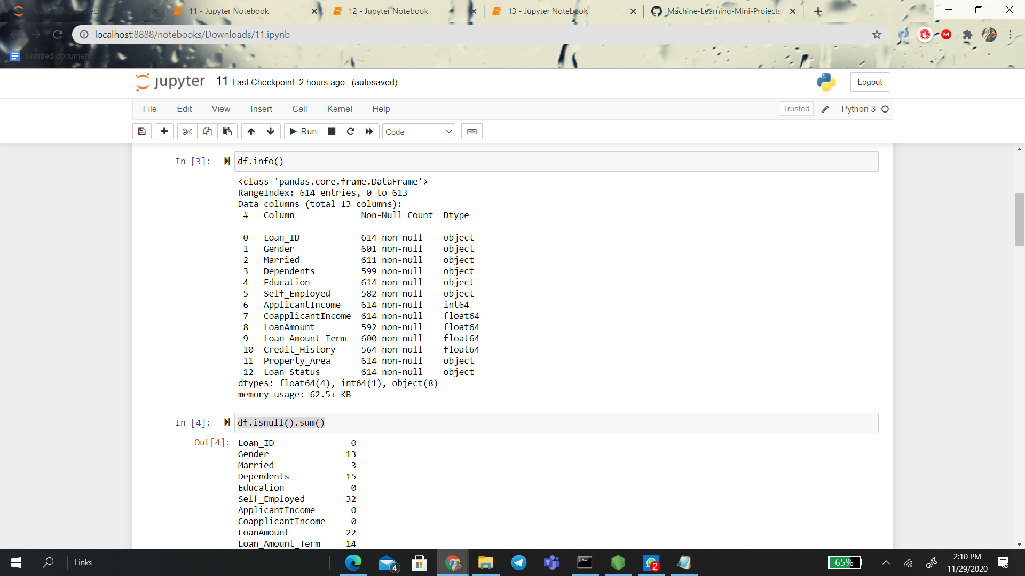

Checking the null values

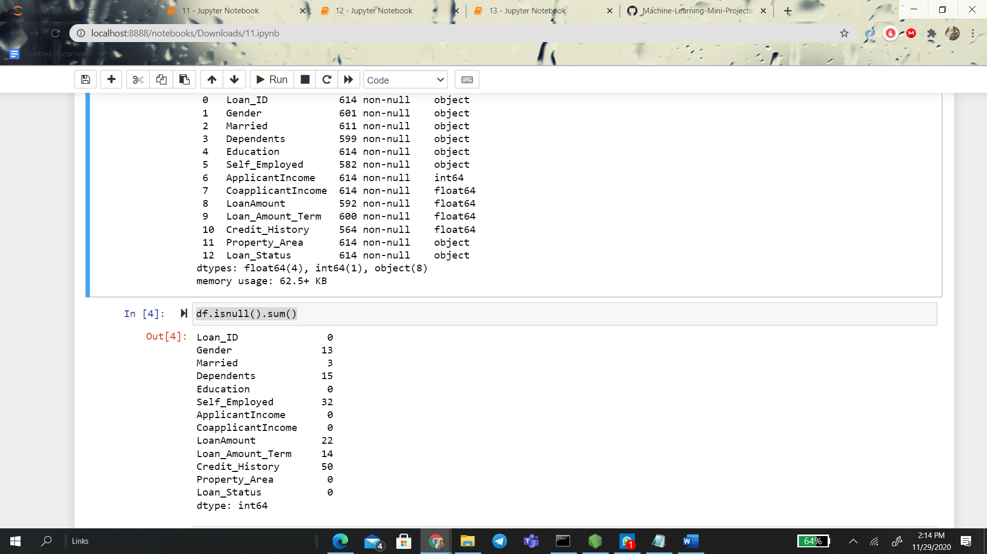

For filling the missing values

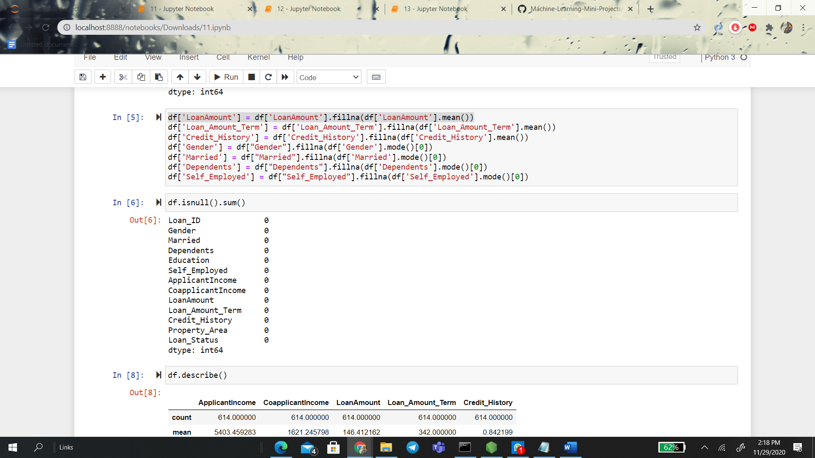

**Data Summarization**:

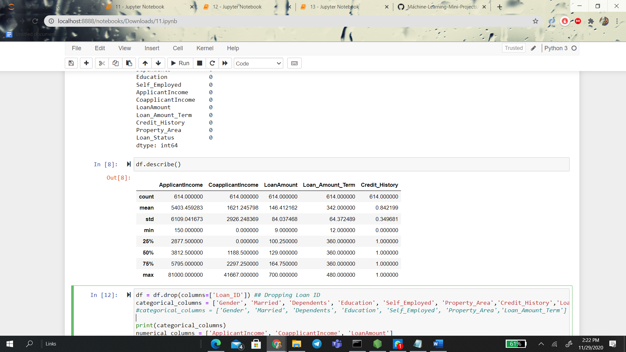

**Data Visualization:**

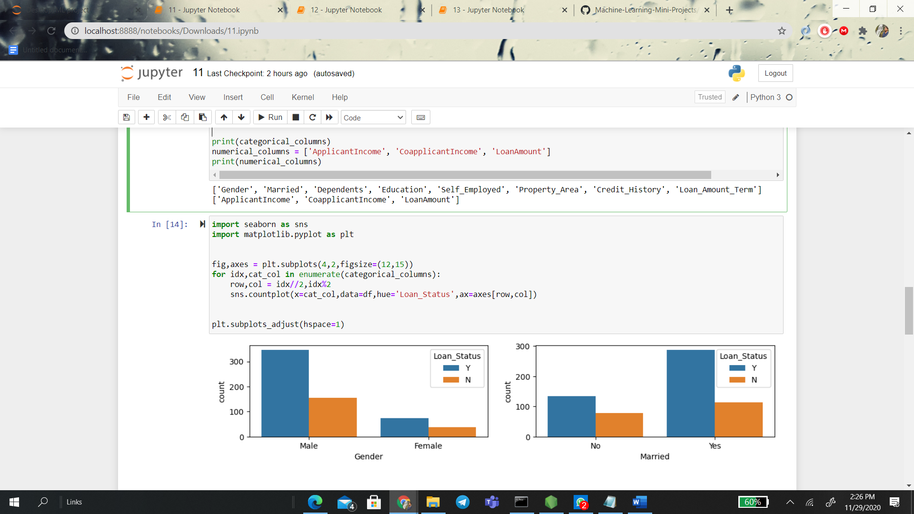

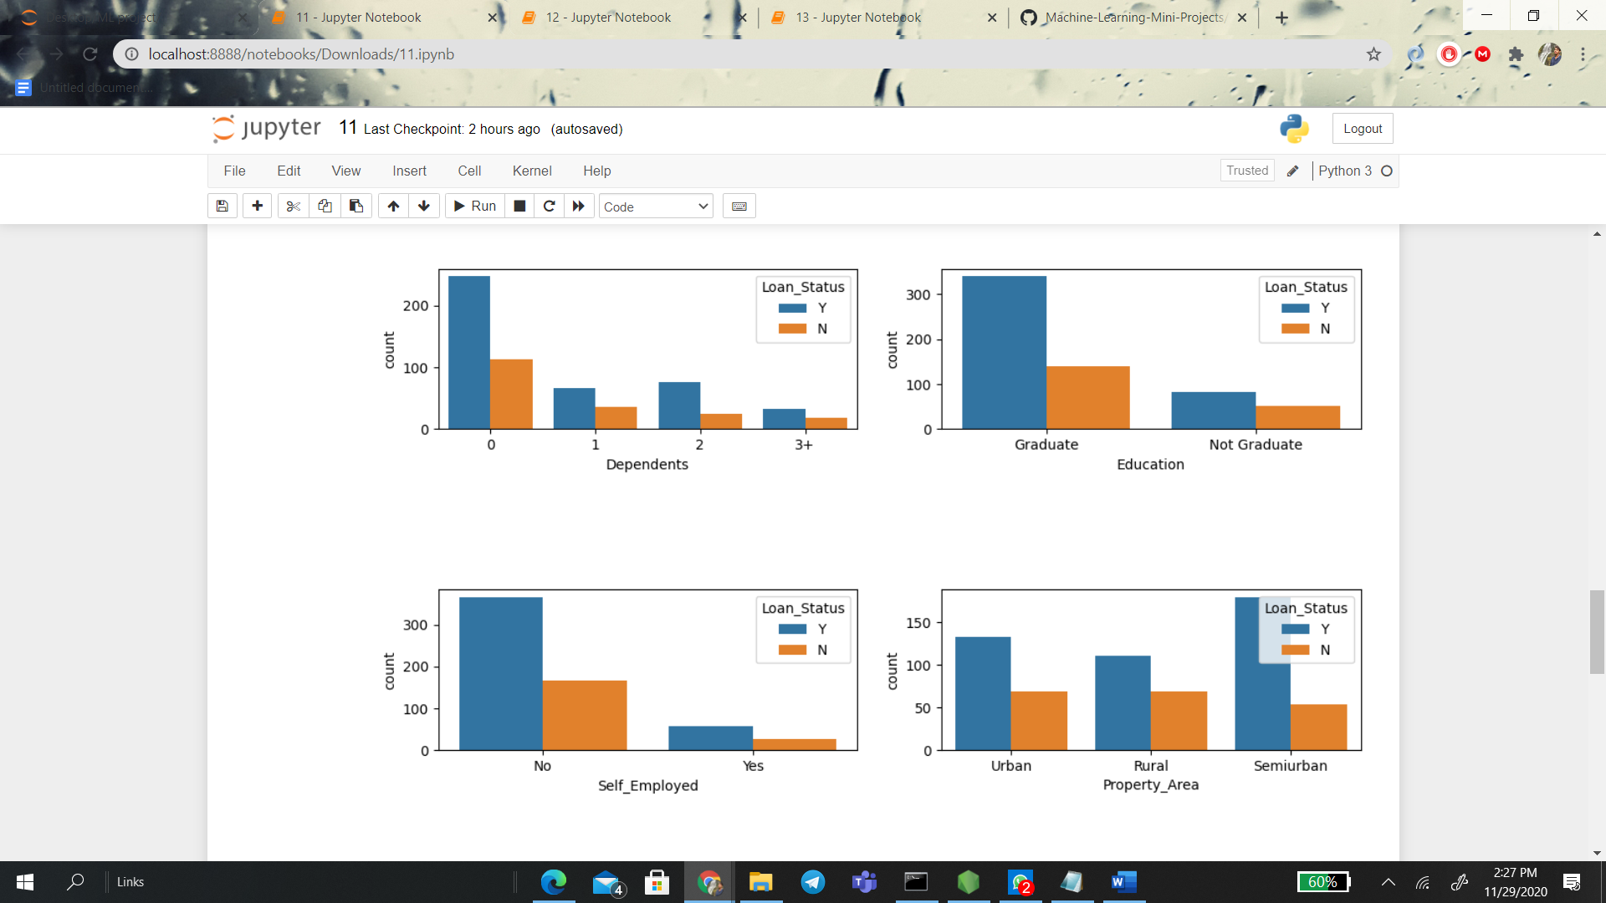

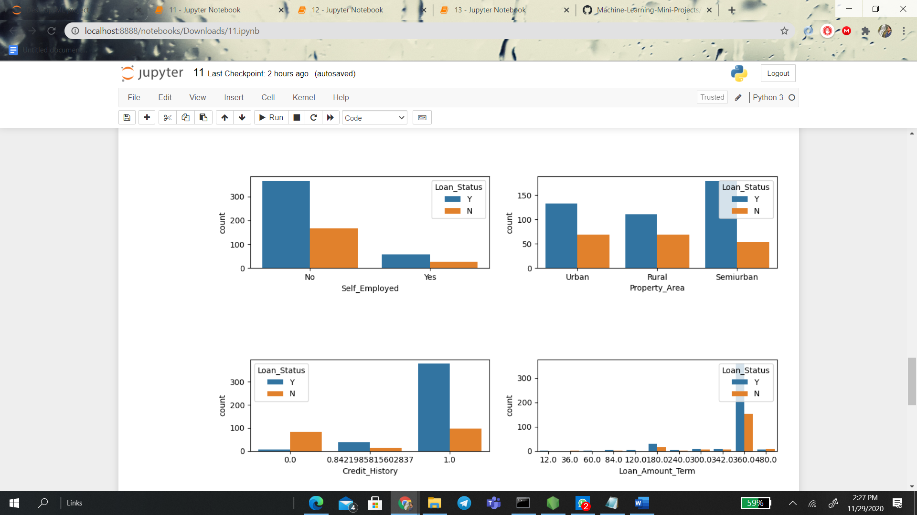

Heat map

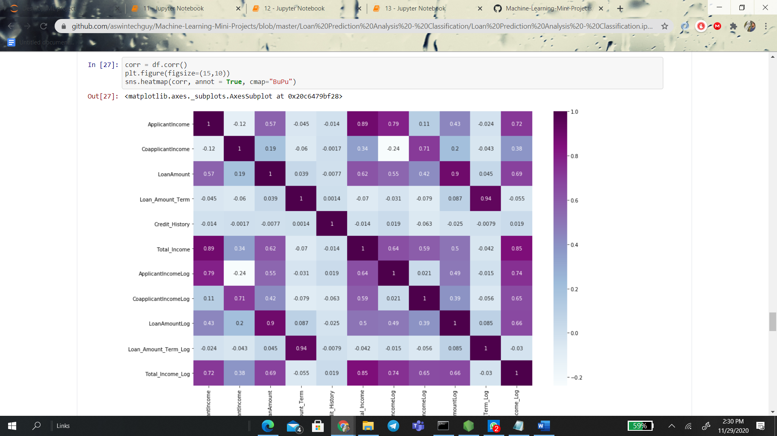

**DATA SET 2**

**Link** <https://www.kaggle.com/ritikmeena/prediction-of-loan-status>

**Preprocessing**

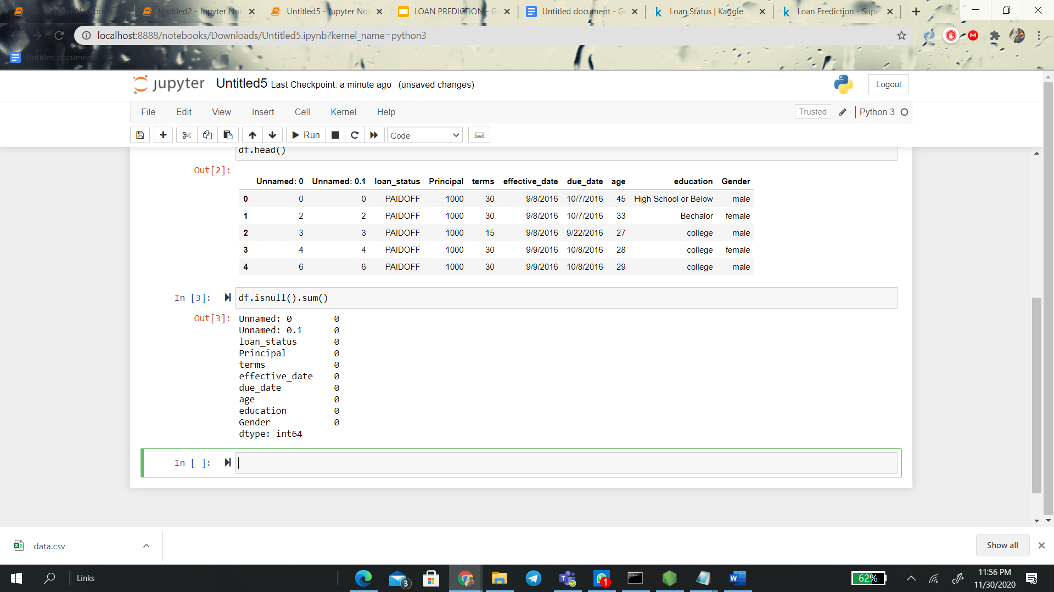

**Data Visualization:**

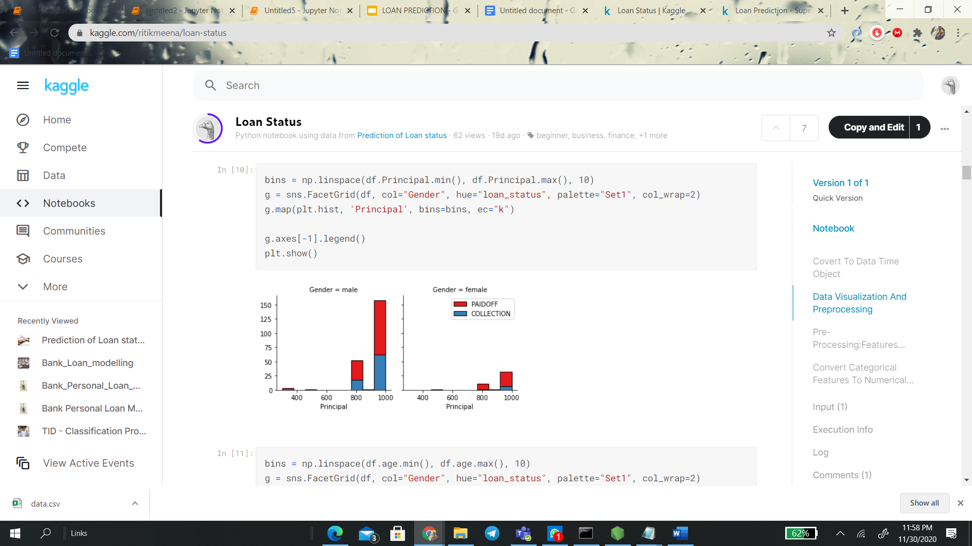

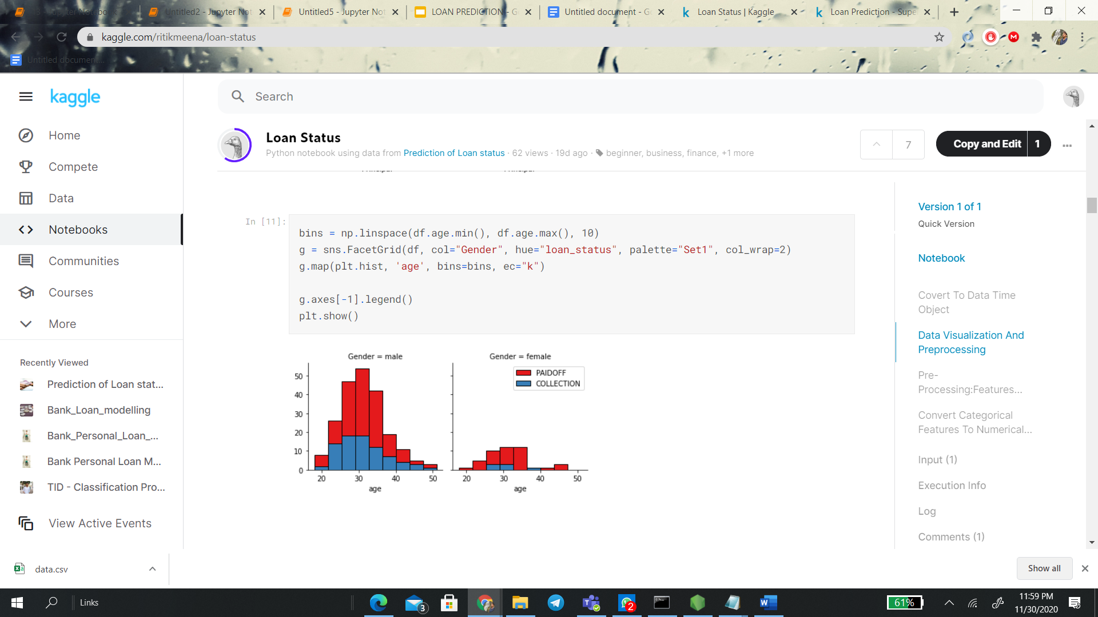

**Data normalization**

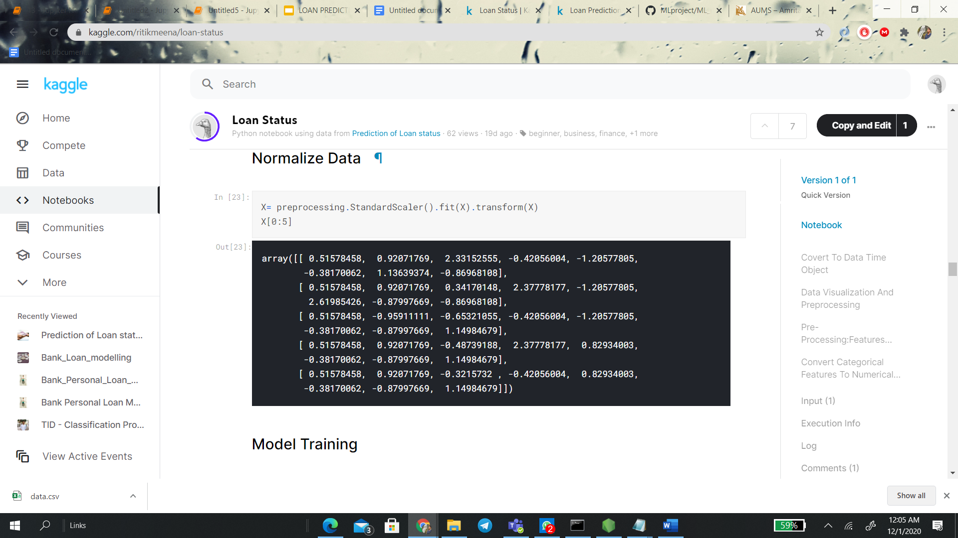

**DATA SET 3**

**Link** [**https://www.kaggle.com/itsmesunil/bank-loan-modelling**](https://www.kaggle.com/itsmesunil/bank-loan-modelling)

**Preprocessing**

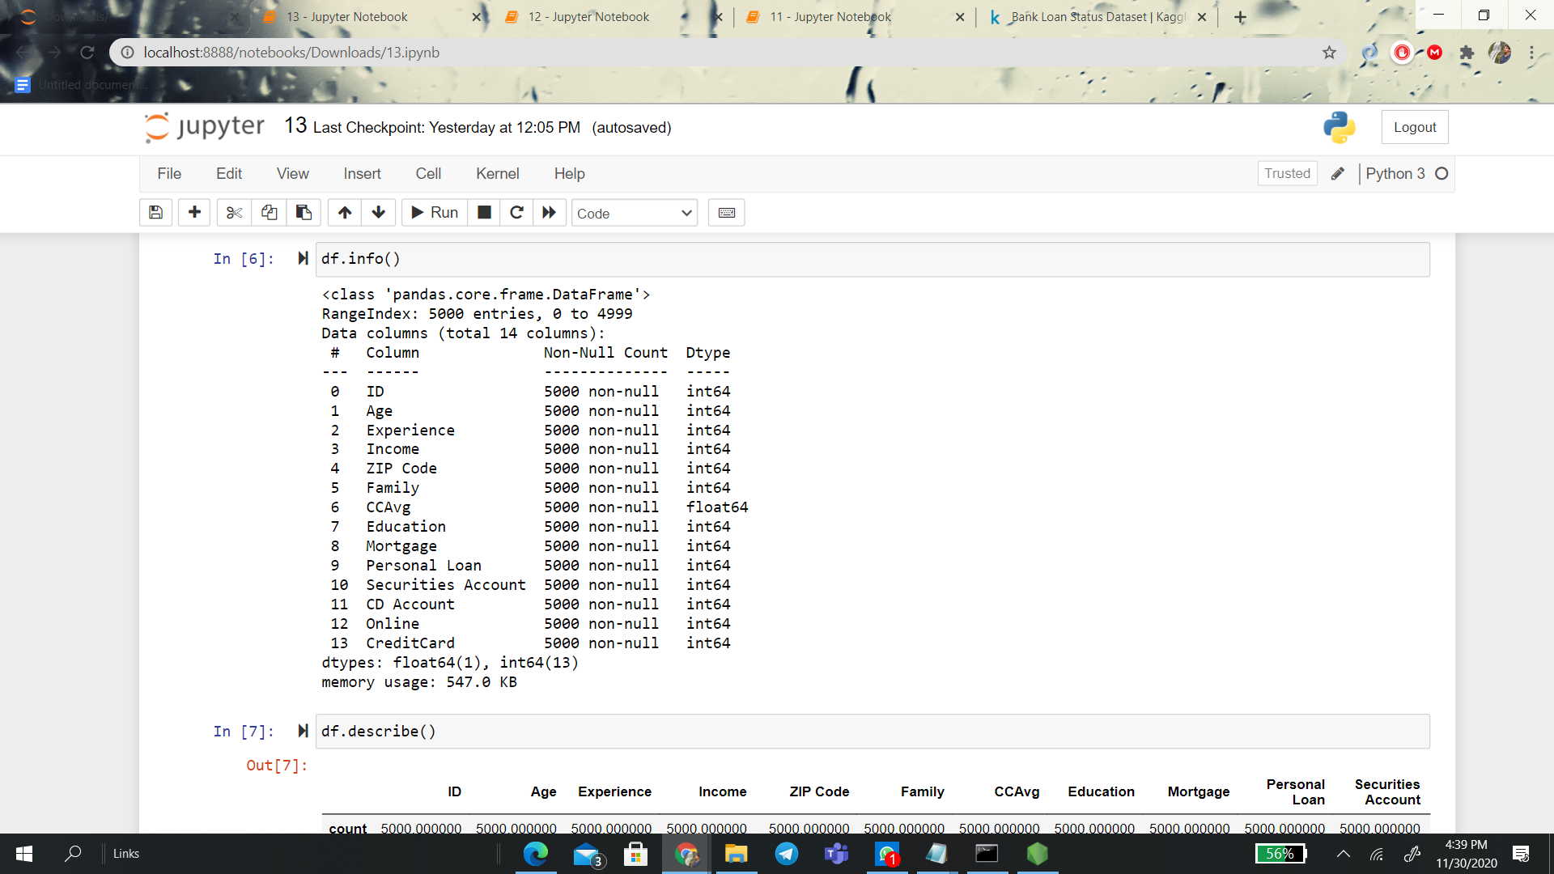

It does not have any missing values

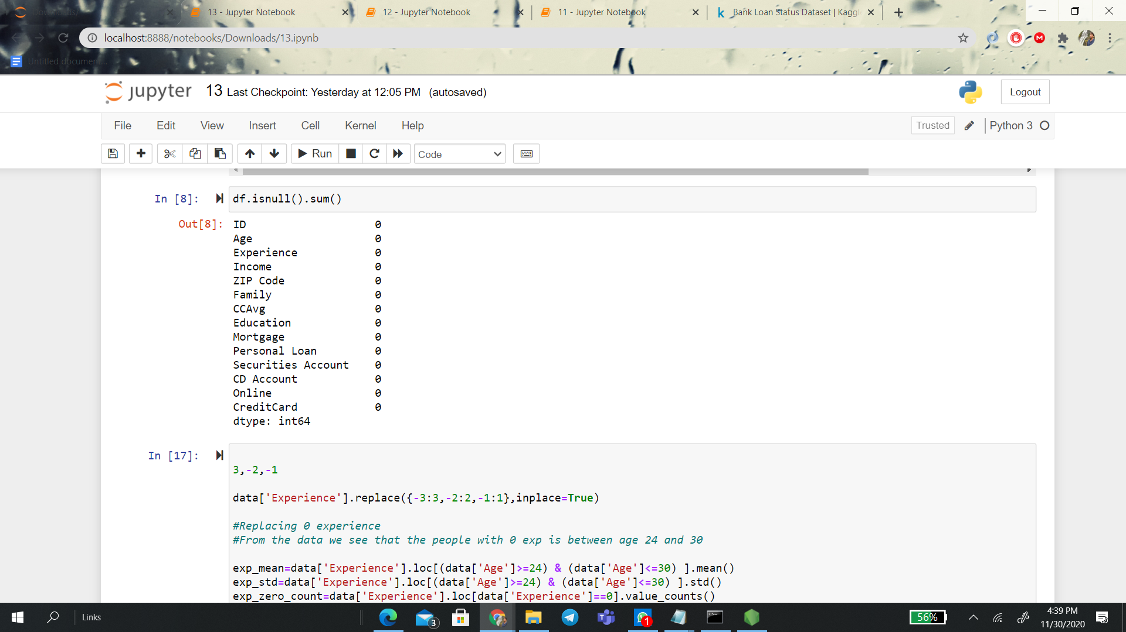

**Data Summarization**:

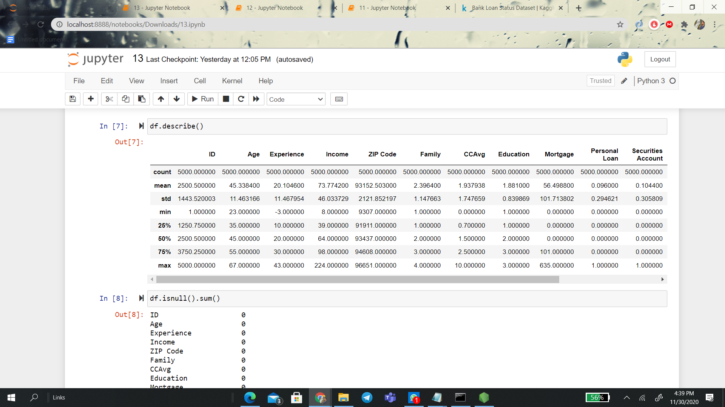

**Data Visualization:**

